1. Using features of Java 11, read the data from a text file (File name: StudentList.txt).

Calculate the count of students and print the names as well as the total count of

students on the screen. (If any line in file doesn’t contain a name, for such a record

blank space should not be printed in the output)

Hint: Use java 11 features of files and String methods to reduce the lines of code to

be written.

**Code:**

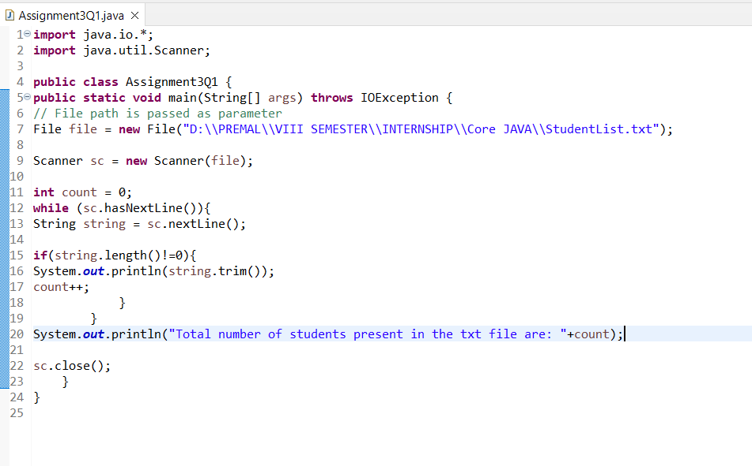

**Output:**

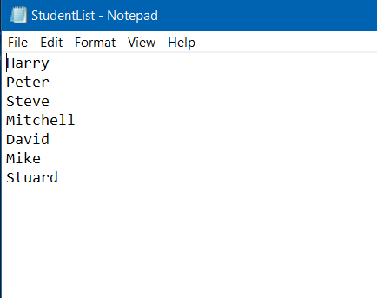

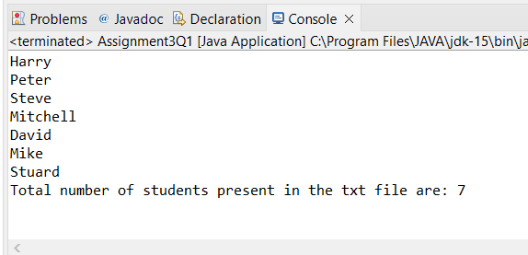

2. Write a program with menu to accept the price of certain items and display their total.

When user selects Option 1: should accept the prices of different products and insert

these prices into first file (each amount to be inserted in a newline in the file). Next,

total of these values should be saved in a new file. Option 2: should allow the user to

view the total of these prices from the second file.

Sample Output:

Select your option (1: Insert New Price, 2: View Purchase Total, 3: Exit)

> 1

> Insert 1st price:

> 100

> Price has been saved to the file

> Do you want to enter price for more items? (Yes/No)

> Yes

> Insert 2nd price:

> 200

> Price has been saved to the file

> Do you want to enter price for more items? (Yes/No)

> No

> Select your option (1: Insert New Price, 2: View Purchase Total, 3: Exit)

> 2

> Total Price of all items is: 300

> Select your option (1: Insert New Price, 2: View Purchase Total, 3: Exit)

> 3

exit program….

Hint: Use java 11 features of files and String methods to reduce the line of code.

**Code:**

**import** java.util.Locale;

**import** java.util.Scanner;

**public** **class** Assignment3Q2 {

**public** **static** String ordinal(**int** i) {

String[] suffixes = **new** String[]{"th", "st", "nd", "rd", "th", "th", "th", "th", "th", "th"};

**switch** (i% 100) {

**case** 11:

**case** 12:

**case** 13:

**return** i+ "th";

**default**:

**return** i+ suffixes[i% 10];

}

}

**public** **static** **void** main(String[] args) {

Scanner sc = **new** Scanner(System.***in***);

**int** count = 0;

**int** price,total= 0;

**int** choice;

**do**{

System.***out***.println("\t\t******************************\t\t");

System.***out***.println("\t\t** 1) INSERT NEW PRICE **\t\t");

System.***out***.println("\t\t** 2) VIEW PURCHASE TOTAL **\t\t");

System.***out***.println("\t\t** 3) EXIT **\t\t");

System.***out***.println("\t\t******************************\t\t");

System.***out***.print("\t\tENTER YOUR CHOICE: ");

choice = sc.nextInt();

**switch** (choice){

**case** 1:

String s = "Yes";

**do**{

System.***out***.print("\t\tInsert "+*ordinal*(count+1)+" price: ");

price = sc.nextInt();

total += price;

System.***out***.println("\t\tPrice has been saved to the file");

System.***out***.print("\t\tDo you want to enter price for more items? (Yes/No): ");

s = sc.next();

count++;

System.***out***.println();

}**while**(s.equalsIgnoreCase("Yes"));

**break**;

**case** 2:

System.***out***.println("\t\tTotal Price of all items is: "+total);

**break**;

**case** 3: System.*exit*(0);

**default** : System.***out***.println("\t\tPLEASE ENTER THE CORRECT CHOICE!");

}

}**while**(choice!=3);

}

}

**Output:**

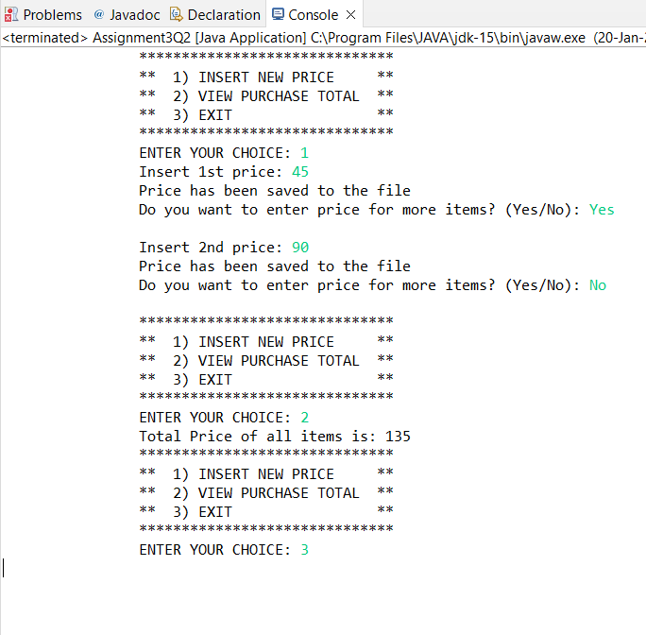

3. Write a code using HttpClient API which sends a GET request

to https://httpbin.org/get, and print out the response header, status code, and

body for the given URL.

Sample output could be (Note: date and other attribute values may differ in your

results):

access-control-allow-credentials:[true]

access-control-allow-origin:[*]

connection:[keep-alive]

content-length:[273]

content-type:[application/json]

date:[Fri, 06 Aug 2021 13:07:41 GMT]

server:[gunicorn/19.9.0]

200

{

"args": {},

"headers": {

"Content-Length": "0",

"Host": "httpbin.org",

"User-Agent": "Java 11 HttpClient Bot",

"X-Amzn-Trace-Id": "Root=1-610d341d-092dc33f698b192a219426d1"

},

"origin": "43.255.221.184",

"url": "https://httpbin.org/get"

}

Code:

**import** java.io.*;

**import** java.net.*;

**import** java.util.ArrayList;

**import** java.util.Date;

**import** java.util.HashMap;

**import** java.util.List;

**import** java.util.Map;

**public** **class** Assignment3Q3 {

**public** **static** **void** main(String[] args)

{

**try**

{

URL url= **new** URL("https://httpbin.org/get");

//open the connection to the above URL.

HttpURLConnection http = (HttpURLConnection)url.openConnection();

URLConnection urlcon= url.openConnection();

Map<String, List<String>>header = urlcon.getHeaderFields();

//print all the fields along with their value.

**for** (Map.Entry<String, List<String>>mp: header.entrySet())

{

System.***out***.print(mp.getKey() + " : ");

System.***out***.println(mp.getValue().toString());

}

System.***out***.println("\nGet Response Header By Key ...");

List<String>contentLength= header.get("Content-Length");

**if** (contentLength== **null**) {

System.***out***.println("'Content-Length' doesn't present in Header!");

} **else** {

**for** (String header1 : contentLength) {

System.***out***.println("Content-Lenght: " + header1);

}

}

**int** statusCode= http.getResponseCode();

System.***out***.println("Status Code: "+statusCode);

System.***out***.println();

System.***out***.println("Complete source code of the URL is-");

System.***out***.println("---------------------------------");

//get the inputstream of the open connection.

BufferedReader br= **new** BufferedReader(**new** InputStreamReader

(urlcon.getInputStream()));

String i;

//print the source code line by line.

**while** ((i= br.readLine()) != **null**)

{

System.***out***.println(i);

}

}

**catch** (Exception e)

{

System.***out***.println(e);

}

}

}

Output:

